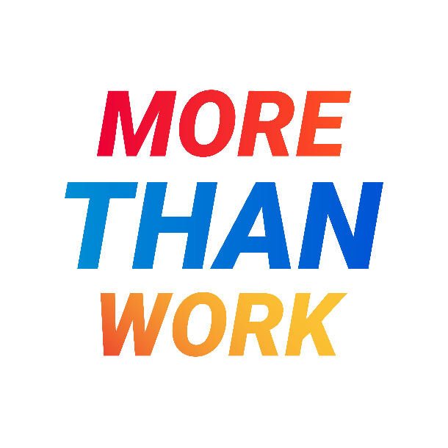
FOR IMMEDIATE RELEASE: [Insert date of release]
[Provider Agency] Joins Statewide Recruitment Campaign Addressing Shortage of Direct Support Professionals (DSPs)
The #MoreThanWork marketing initiative seeks to attract new DSPs to provide critically needed support for people with developmental disabilities.
CITY OF AGENCY LOCATION, N.Y. – [provider agency] is a proud participant in the statewide recruitment campaign addressing the serious shortage of Direct Support Professionals (DSPs) that is affecting human services organizations across that state and nation. The #MoreThanWork campaign highlights the crucial role DSPs play in supporting New Yorkers with developmental disabilities.
[INSERT AGENCY LEADER QUOTE HERE.]
The #MoreThanWork campaign includes more than 200 nonprofit service-providing agencies across New York who are ready to employ candidates in fulfilling careers in direct support to people with developmental disabilities.
The campaign seeks to educate the public and, in particular, the job-seeking public, about the importance and fulfilling nature of direct support work and to connect potential job candidates directly to opportunities supporting New Yorkers with developmental disabilities across the state.

#MoreThanWork is now visible throughout New York communities, through tv and radio advertisements and on social and digital media. It points interested job seekers to a central website www.directsupportcareers.com where they can search and find service providers near them to learn more about the career opportunities that are available.

To learn more and view current job opportunities , visit the #MoreThanWork campaign website at http://www.DirectSupportCareers.com/ or or [provider agency] website link.
About #MoreThanWork:
Funded by the Office for People With Developmental Disabilities (OPWDD), #MoreThanWork is a campaign highlighting the important role of Direct Support Professionals (DSPs). Developed in March 2024, the campaign aims to address the DSP workforce shortage and elevate the vital work these professionals do in the lives of people with developmental disabilities.
About provider agency:
###

Media Contact:
Matt Potolski | Baker Public Relations
O: 518.426.4099 | M: 518.698.4032
matt@bakerpublicrelations.com
www.bakerpublicrelations.com

